Follow the steps below to add a new deposit:

First you need to successfully log in to the software

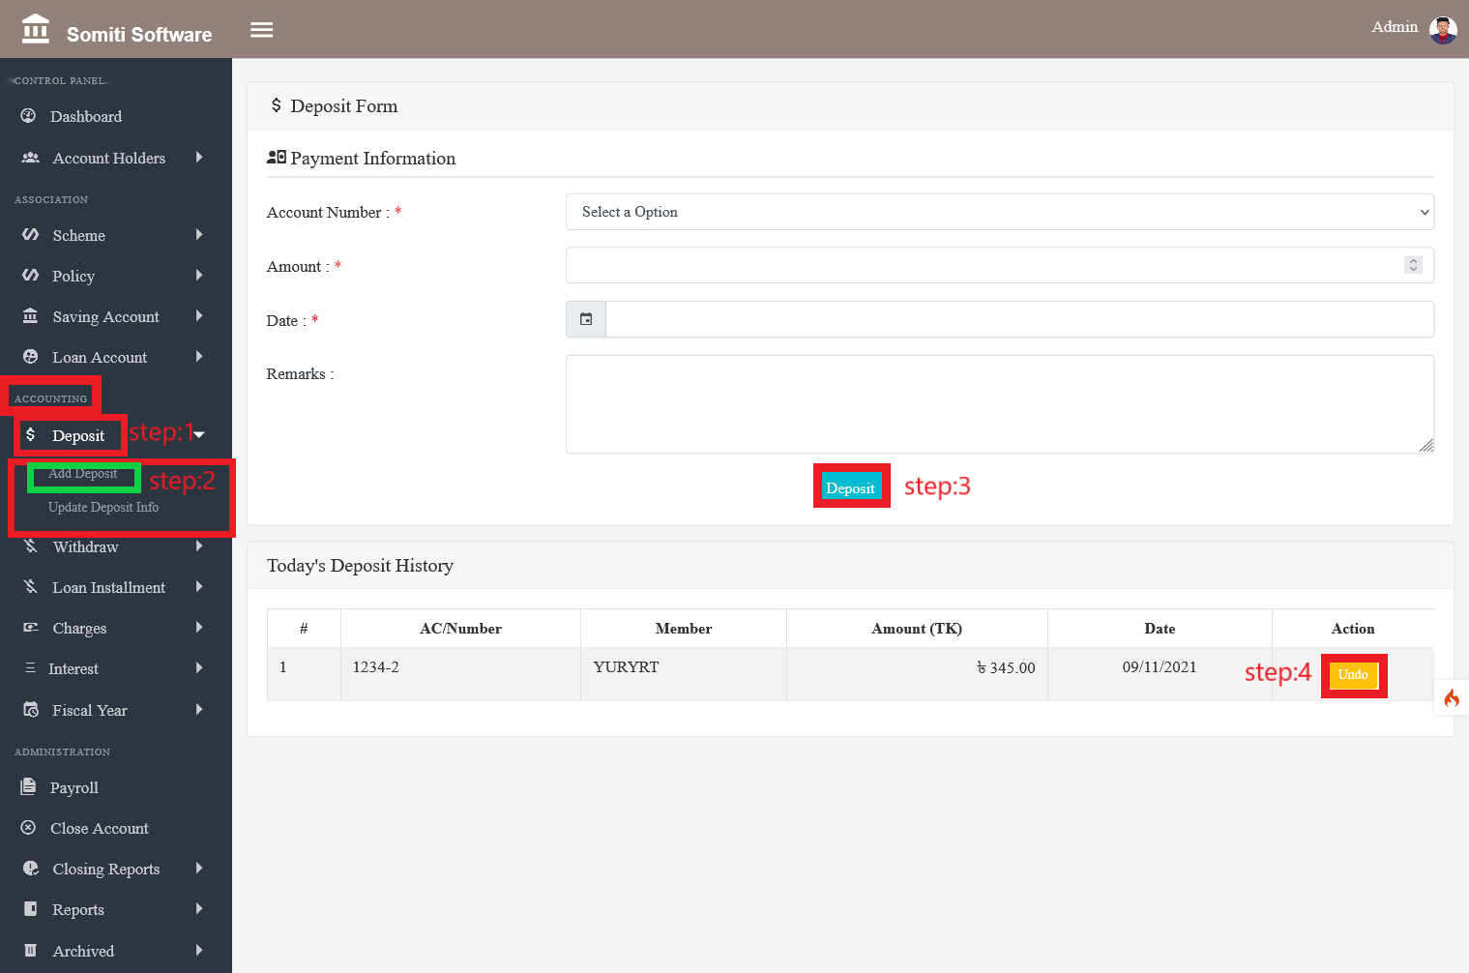

Step-1

Click on the **Deposit** section from **Accounting**:

Step-2

After clicking on the Deposit section, a new list will appear. From there, click on the **Add Deposit** section.

Clicking on the section will bring up a form. Provide all the information required in the form accurately.

Step-4

When the information is provided, click on the **Deposit** button.

Step-5

If you want to delete all the information given in the form, click on the **undo** button.